**LAB EXERCISE-4**

K.HEMA ANMISHA

17MIS1059

1. Write a shell script to raise an error message when a file name with special characters is created.

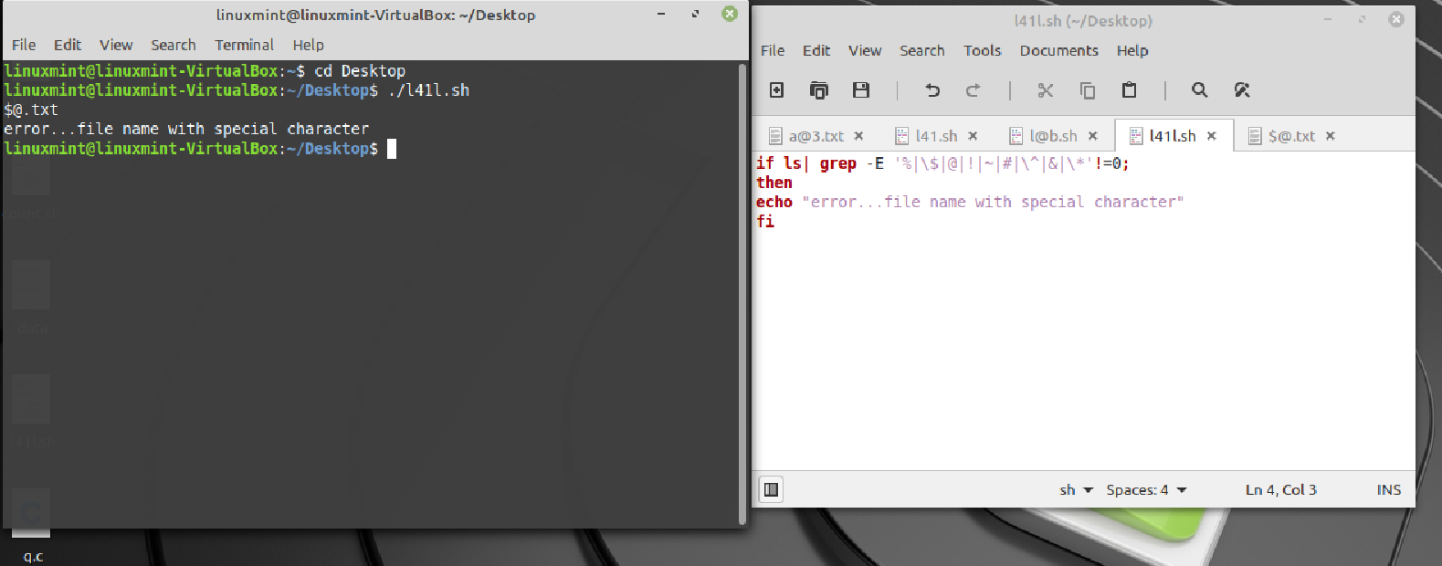

2. Write a shell script to send an email stating "File Executed" whenever a particular file is executed.

